Question 20

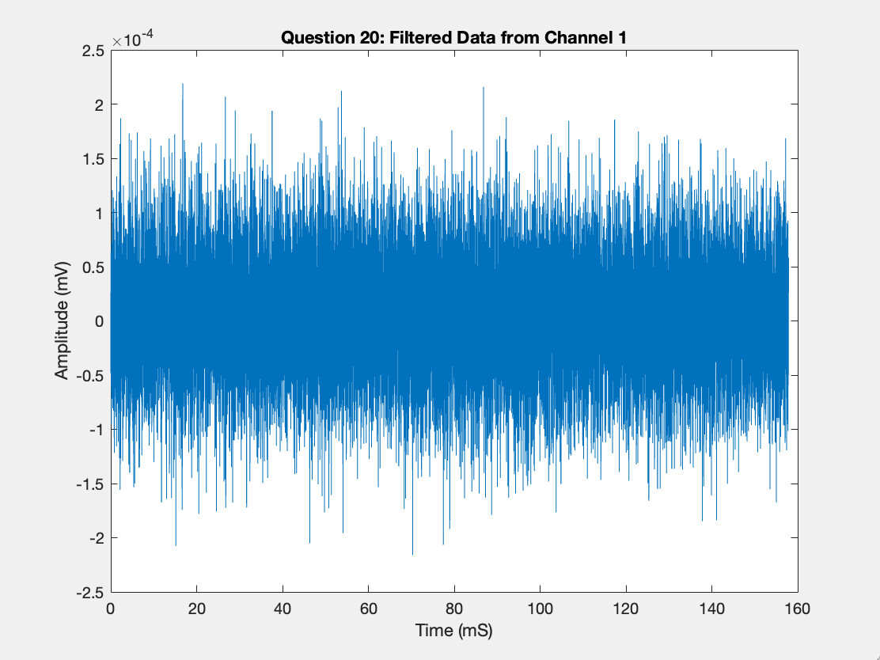
Figure 1. The figure shows butter filtered visually evoked data collected from visual cortex in rats. The data was filtered on low bandpass, at order 2, and cutoff 300 hertz to better visualize and reduce noise of data. Higher orders excluded relevant information. The data is plotted from channel one, which is found closest to cortex. The waveform is plotted with Amplitude, measured in millivolts, on the y axis, and time, measured in milliseconds, on the x-axis.

Question 21/22

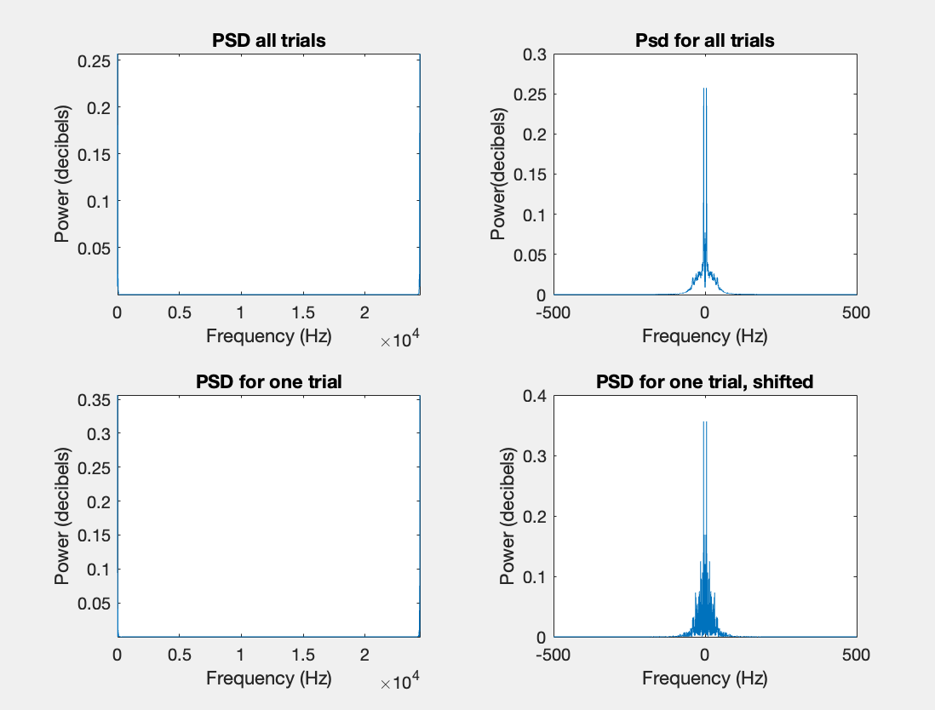
Figure 2. PSD data was calculated for all trials and also just for one trial. There is a significant difference in that the PSD for all trials is clustered around 0 Hz, however, the PSD for one trial is clustered around the edges of the graphs.

Question 23

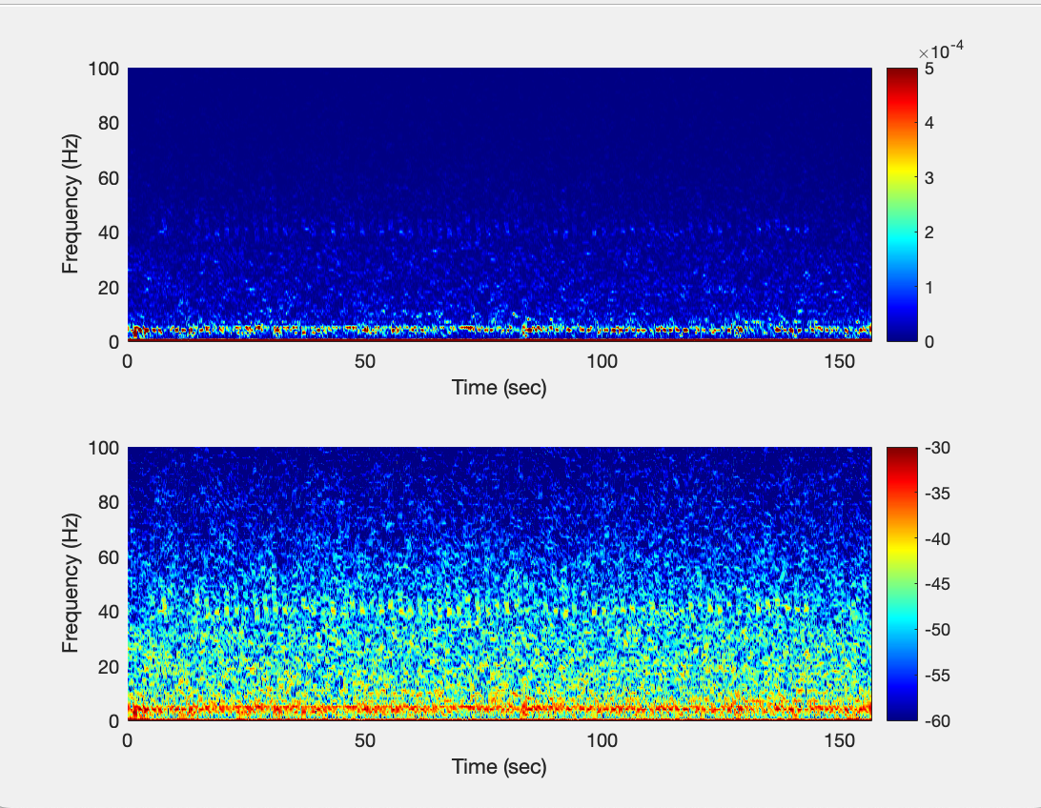
Figure 3. The spectrogram for channel 3 was filtered over 1 second, every .1 seconds. It seems as if there is activity closer to 40 Hz in the top graph and activity clustered between 20-60 Hz in the bottom graph.

Question 24
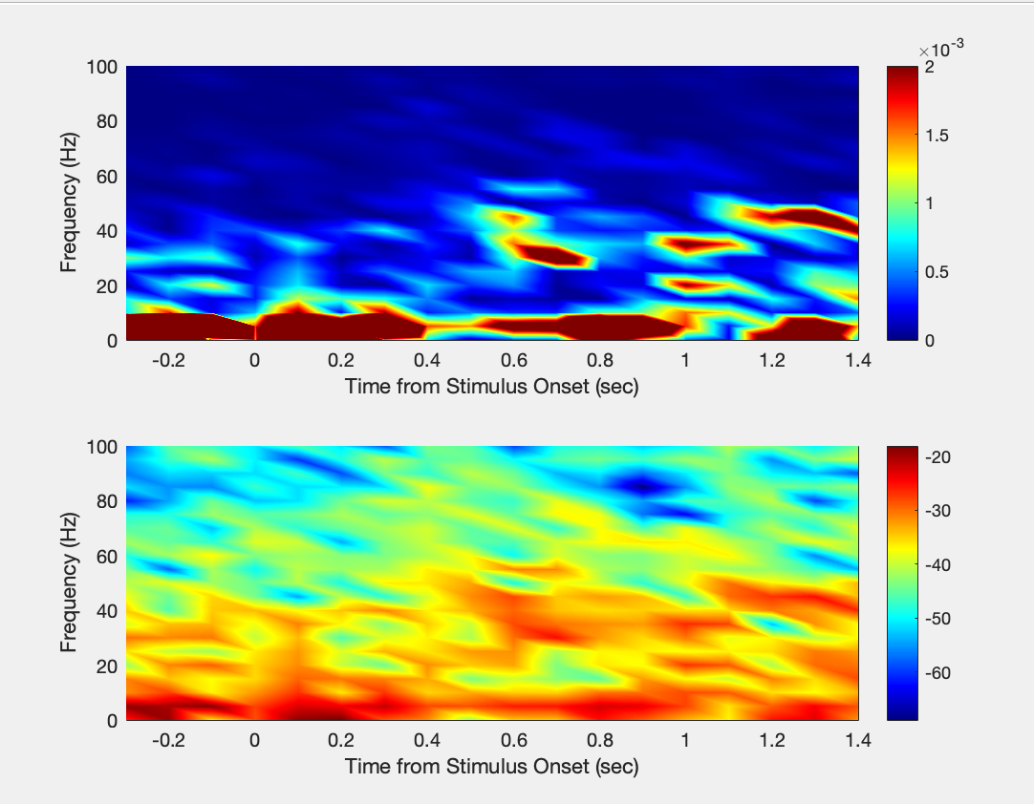
Figure 4. Spectrogram data was calculated and averaged every .1 seconds and shows that there is more intense activity at certain frequencies. In the top graph, there appears to be more activity in the 40-60 Hertz range around .6 and 1.2 seconds. Based on these observations, it seems that visually evoked activity is observable around 40 Hz.

Accompanying Questions

25. Intracellular and extracellular recordings are different for synaptic and action potentials in terms of the places electrodes are placed and the kind of information they collect. Extracellular recordings have the electrodes placed outside the neuron but close enough to groups of neurons in the extracellular space that they can gather information. The electrodes do not pierce the neurons themselves. They capture the electrical information of multiple neurons spikes and usually this information is less specific and less sensitive to collecting information that would be below synaptic potentials. Since information is being collected from many neurons, they would have to be larger in size and have more surface area than intracellular electrodes. Conversely, intracellular recordings are made by putting a smaller electrode inside one singular neuron which would penetrate the neuron and collect information about electrical potential inside the neuron. This is very specific to an individual neuron’s action potential, membrane potential, and can gather information about below threshold activity because it is able to detect really small changes inside the neuron. Additionally, glass pipettes are common for intracellular recording. Since these are two very different ways of collecting information and they differ in the actual information collected, you couldn’t use the same electrode to do different types of recording. Actually, intracellular needs to be smaller, able to conduct, and have a thinner tip which is sharp so it could penetrate the neuron’s cell wall. Extracellular would need to be larger so it could collect more information and also would not need to be glass.

26. In the context of this assignment, I saw that spectrograms help us understand information about how neuronal populations have power of different frequencies and we can see how neurons might have synchronized activities at certain times. Sometimes spectrograms could show us periods where there is a lot of neuronal firing or activity at once. This is significant because we can gather information about how neurons are reacting during certain periods of time or in response to certain stimuli.

27. To look at information below the cut off frequency, we have used low pass filtering because it allows us to examine only lower frequency information and also we can use time-frequency bins where the data collected is split into bins that would have specific frequency and time ranges. There are additional methods that I am less familiar with including statistical analysis that might help us look at information below the cut off frequency, such as cross-correlation.

Extra Credit Part E : Compute CSD

- I was not able to plot the CSD or average CSD but attempted to write the code.

